ACCESS MANAGEMENT
System defined roles and its users:
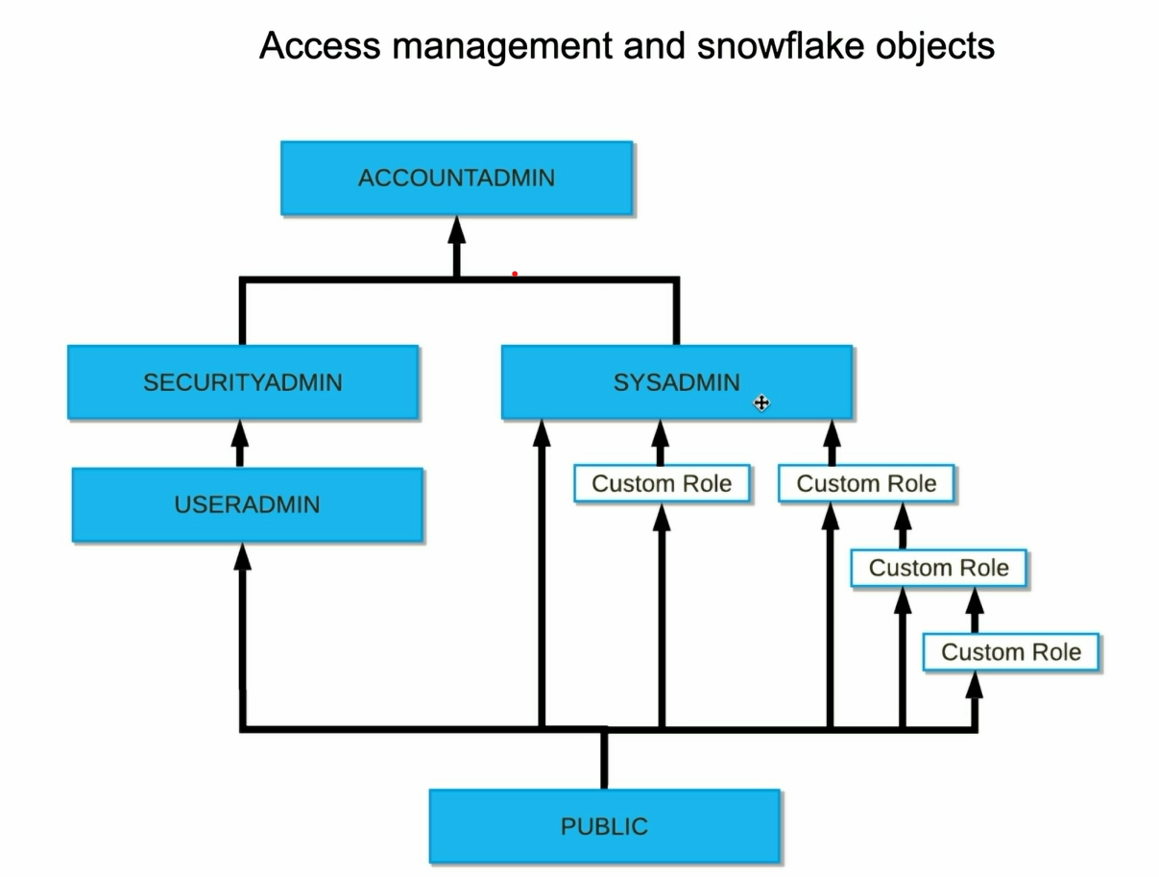
As you see above and already know that they are system defined roles, the top role is account admin. Under it we have security admin and sysadmin which are the children of account admin. Under security admin we have user admin and there is public role and pubic role is inherited by all the user admin and sysadmin
When you create a custom role, snowflake recommends that you directly assign it to the sysadmin (why it has to be assigned?? We will see it)
If you have hierarchy of custom roles, it is recommended that you assign the top role to sys admin and this custom role is actually tree of the roles.

ACCOUNTADMIN:
As mentioned earlier this is the top level role or most powerful role and should be granted to very limited people say 2.
- It can configure parameters at account level
- View billing and manage it and can terminate the execution of SQL statements any time.
- When your account get created the first user is assigned the ACCOUNTADMIN role

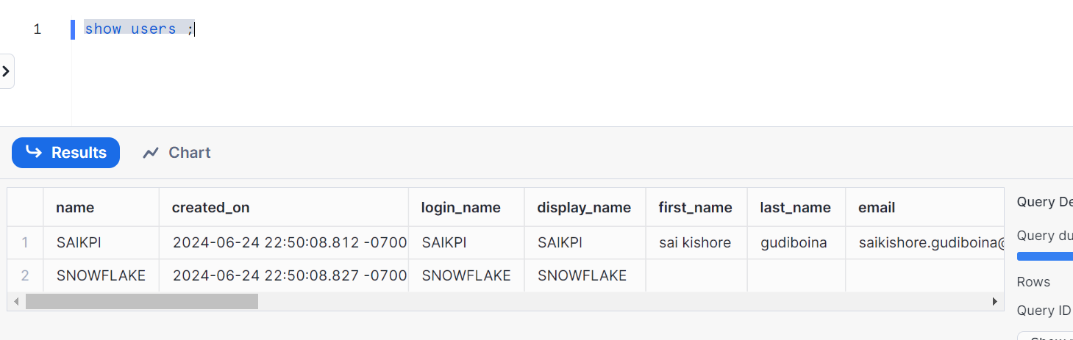
So let’s create one more accountadmin users - Nick. This will make two accountadmin users as recommended by snowflake
Create another user having account admin role
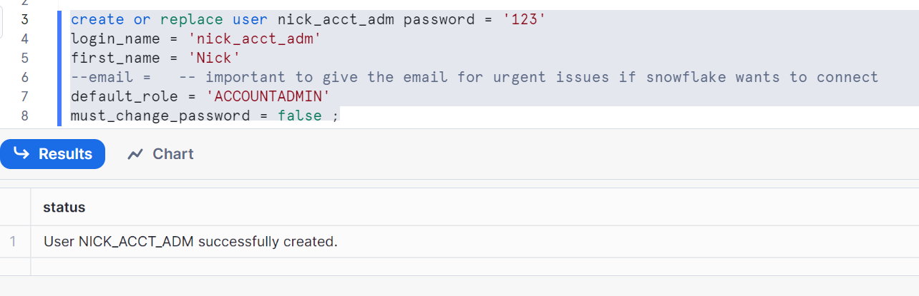
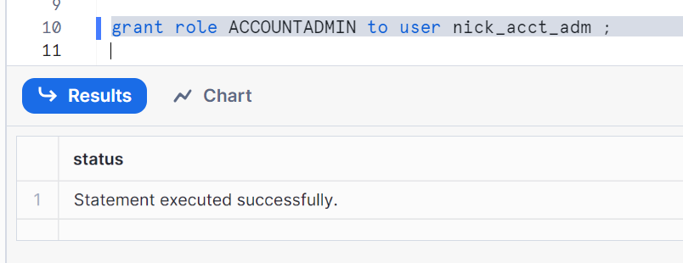
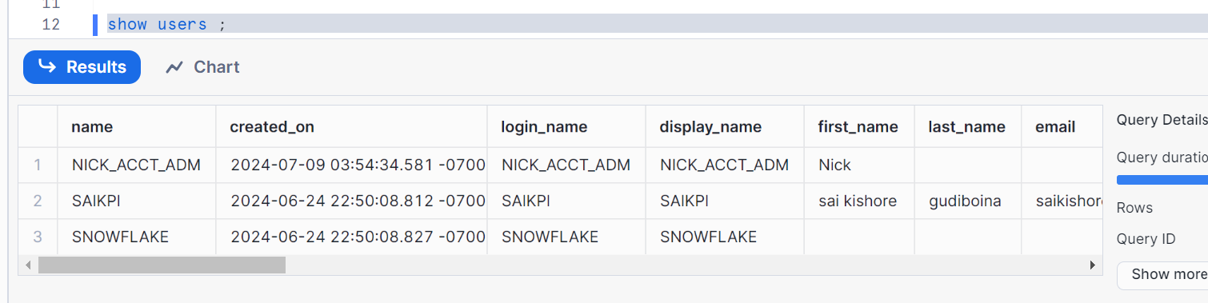
Let’s see what the grants are given to user nick_acct_adm
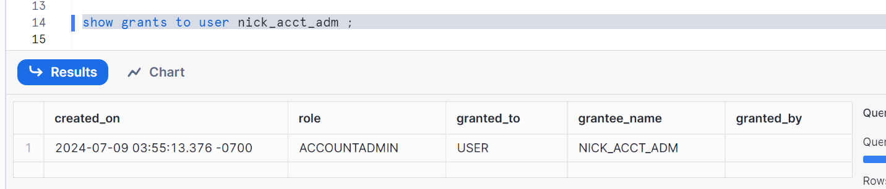
MFA (multi factor authentication) authentication should be enabled for accountadmin users for security reasons

To setup MFA, follow the steps
Go to home page
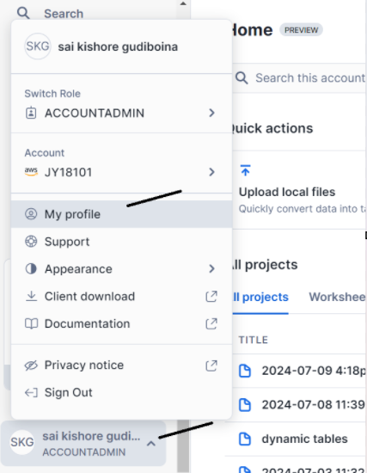
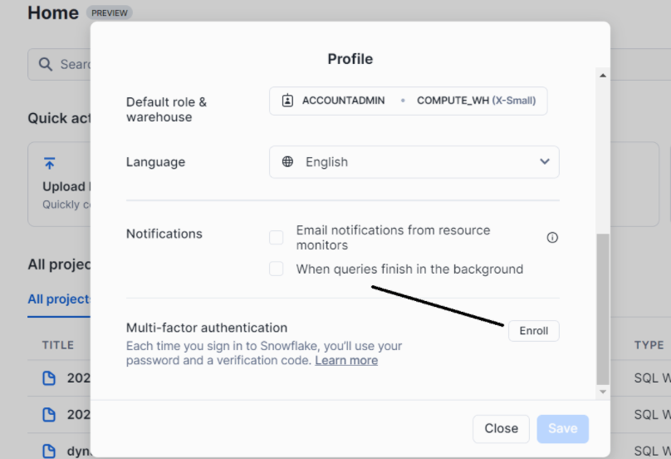
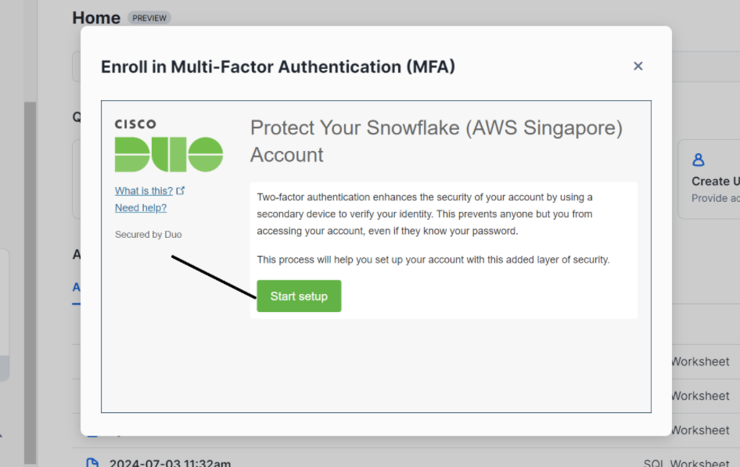
Then give your mobile number and set up MFA
If you want to disable you can run the following command
Alter user <username> set DISABLE_MFA = true;

Security admin (Security administrator):
Manage object grant globally - modify or revoke any grant & Inherits useradmin
Security admin user basically manages the objects grant globally. As we have seen above, Security admin is actually having user admin as well

Let’s create
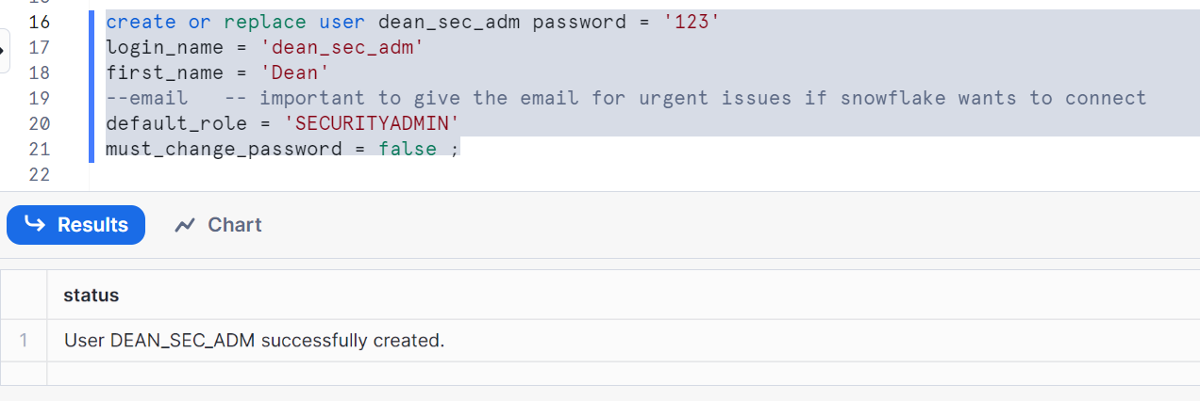
Let’s see the grants on it
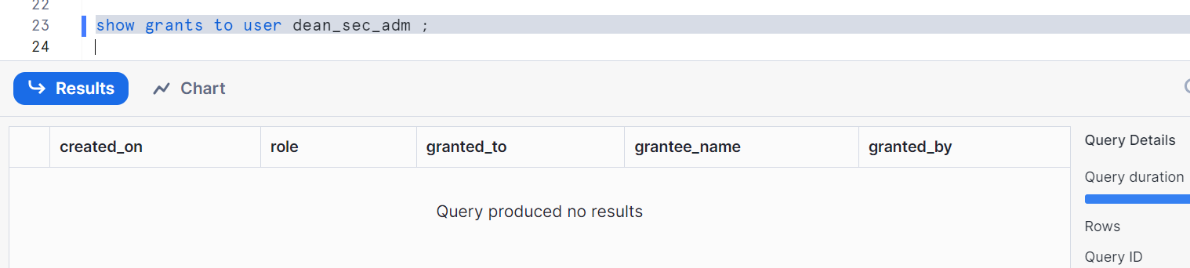
Grant role securityadmin to this user
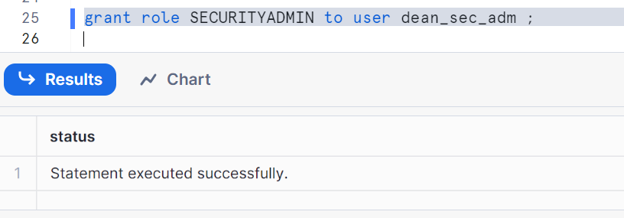
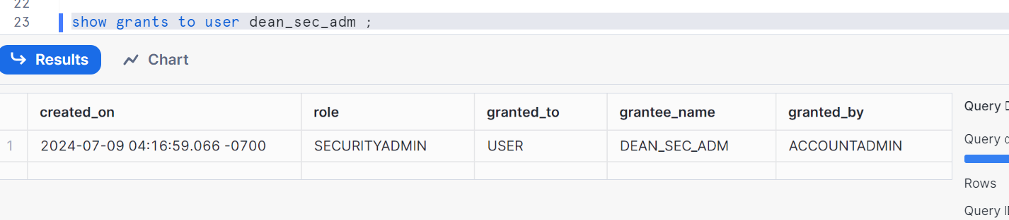

USERADMIN (users and roles administrator):
It is responsible to create the users and roles into the system

Now let’s create a user having user admin access who can create users and roles
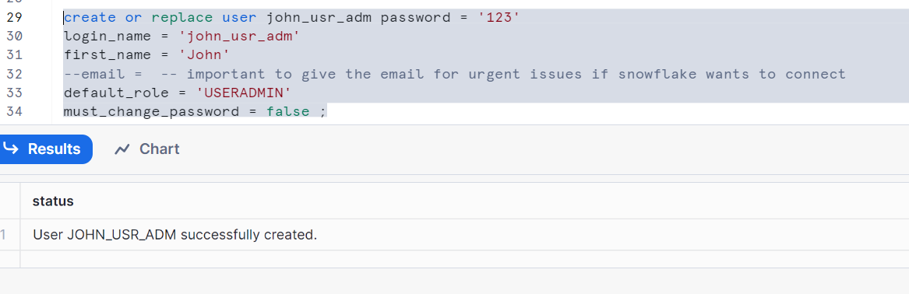
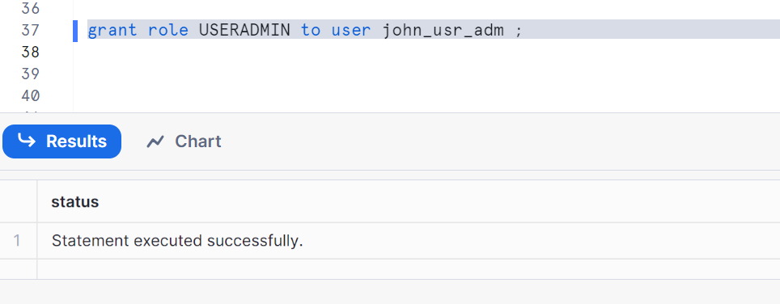
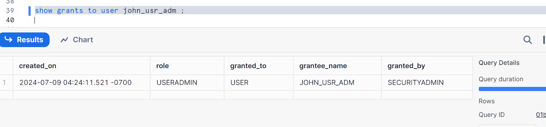
Login as user admin to create users and roles

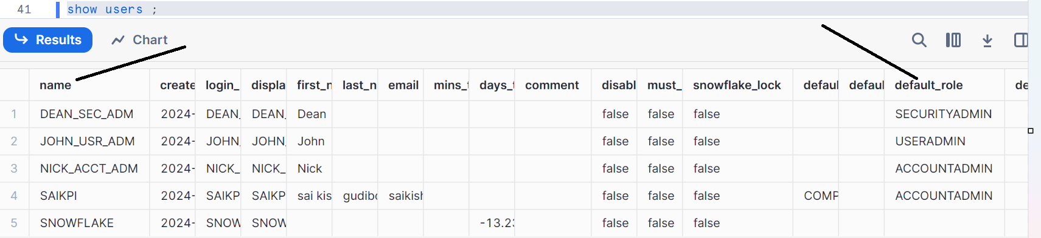

SYSADMIN (system administrator):
Sysadmin user is important to create the warehouses, databases and the objects
We need to create a user having user admin access who can create warehouse, databases and other objects
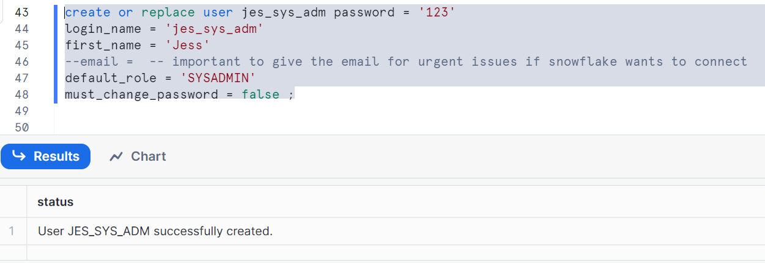
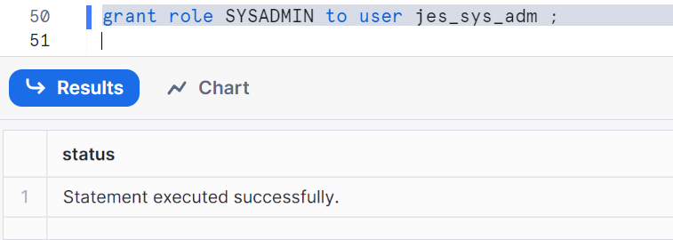
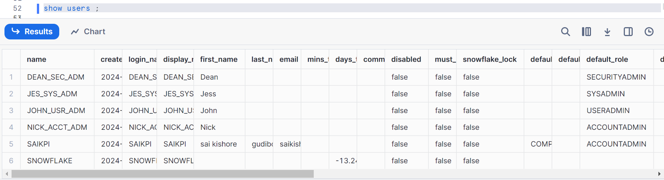

So all the 4 users are created and we will see in next post of how these users control the system and give it to developers / QA and other users

